CRUISE REPORT
Cruise Number: DY15-07

Ship:
NOAA Ship Oscar Dyson
Area of Operations:
Western Gulf of Alaska. Data from DY15-07 in conjunction with NW1501 Leg 2A (formerly NWE1501 Leg
2A) completes Eco-FOCI survey coverage of the western Gulf of Alaska.
Itinerary:
Date depart / port: August 20, 2015 / Kodiak, AK
Date arrive / port: September 2, 2015 / Dutch Harbor, AK
Participating organizations:
NOAA - Alaska Fisheries Science Center (AFSC)
NOAA – Pacific Marine Environmental Laboratory (PMEL)
NOAA – Office of Science and Technology (OST)

Chief Scientist:
Steven Porter M / AFSC / Eco-FOCI
Personnel:
Alex Andrews M / AFSC / EMA
Casey Debenham M / AFSC / EMA
Annette Dougherty F / AFSC / Eco-FOCI
Kathy Mier F / AFSC / Eco-FOCI
Candace Nachman F / OST
Melanie Paquin F / AFSC / Eco-FOCI
Peter Proctor M / PMEL
Sigrid Salo F / PMEL
Cruise Objectives:
Conduct a fisheries (midwater trawl) and oceanographic survey to:
- Extend time series of age-0 Walleye Pollock abundance in the western Gulf of Alaska;
- Describe the community structure, biomass, energetic status of pelagic nekton;
- Collect age-0 Walleye Pollock associated prey and measure environmental variables that potentially affect Walleye Pollock ecology; and
- Occupy a series of cross-shelf transects of CTD stations to examine cross-shelf physical and chemical oceanography.

Summary of Operations:
The primary objective of the cruise was to conduct a trawl survey for age-0 Walleye Pollock and a bongo survey to collect age-0 Walleye Pollock associated prey from Kodiak Island to Unimak Island. Two cross shelf lines of CTDs were occupied to provide information on cross shelf flow.

Samples Collected
20cm bongo (20BON) 74
60cm bongo (60BON) 74
Anchovy trawl (ANCHO) 67
Shrimp trawl (SHRIMP) 7
Seabird FastCAT CTD (CAT) 74
CTD with bottle samples (CTDB) 10
Summary of Cruise
Oscar Dyson departed Kodiak, AK on August 20, 2015, and arrived at Dutch Harbor, AK on September 2, 2015. Some of the stations located near the Shumagin Islands could not be occupied due to bad weather making conditions unsafe to deploy gear. Bad weather also prevented occupation of 3 of the 26 Eco-FOCI index sites used in the time series of age-0 pollock abundance. At each grid location, a bongo tow was conducted first to collect zooplankton followed by a Stauffer (aka anchovy) trawl to sample age-0 Walleye Pollock and other forage fishes. The gear for zooplankton sampling was a 60-cm bongo frame with 0.505-mm mesh netting paired with a 20-cm bongo with 0.153-mm mesh. A FastCat was mounted above the bongo to provide depth, temperature, and salinity data. Bongo tows were to 200 meters depth or 10 meters off the bottom where water depth was shallower. For each bongo array, Net 1 was preserved in 1.8% formaldehyde, and buffered with sodium borate. At selected stations, zooplankton from Net 2 from both arrays were sorted and counted and then discarded.

The Stauffer trawl was deployed to a depth of 200 meters, or 10 meters off the bottom, whichever was shallowest. A SBE-39 was deployed on the headrope as a backup depth sensor, and data were saved. Net depth was monitored using the ship’s Simrad ITI (trawl eye) and FURUNO system. Standard trawl operations were used for deployment. The trawl was fished over a double-oblique path.

Walleye pollock (all age classes), Pacific cod, rockfishes, sablefish, capelin, eulachon, and flatfishes were sorted from the catch. Flatfishes were sorted to species if possible. Standard length (SL) was the body-length metric for age-0 Walleye Pollock. Fork length (FL) was the body-length metric for age-1+ Walleye Pollock. The following groups were frozen for subsequent examination in the laboratory: age-0 Walleye Pollock, age-1 Walleye Pollock, age-0 Pacific Cod, age-0 rockfish, and flatfish species (flatfish <100 mm TL). They were flash frozen in the –80ºC freezer and then moved to the –20ºC freezer.

CTD transects: Transects were occupied for CTD cross-shelf analysis (Figure 1). At each transect location a CTD (with bottles) was conducted. All hydrographic casts included high-resolution vertical profiling of water properties (including temperature, salinity, chlorophyll fluorescence, PAR, dissolved O₂) to within 10 m of the bottom using a Seabird 911Plus CTD. Discrete oxygen samples were collected, and that data were used to calibrate the CTD oxygen sensors. Nutrients were collected and frozen for analysis at a later date at the NOAA laboratories in Seattle.

Days Lost to Weather:
No days were lost to weather (i.e., the ship did not transit to a protected bay and wait for the weather to
improve) but bad weather did slow operations down so that less stations were occupied than was originally
planned.
Days Lost to Equipment Failure:
0
Recommendations:
None
Acknowledgments:
The scientific party would like to acknowledge the hard work and support of the officers and crew of NOAA Ship Oscar Dyson.

Attachments:

Figure 1. Station Map

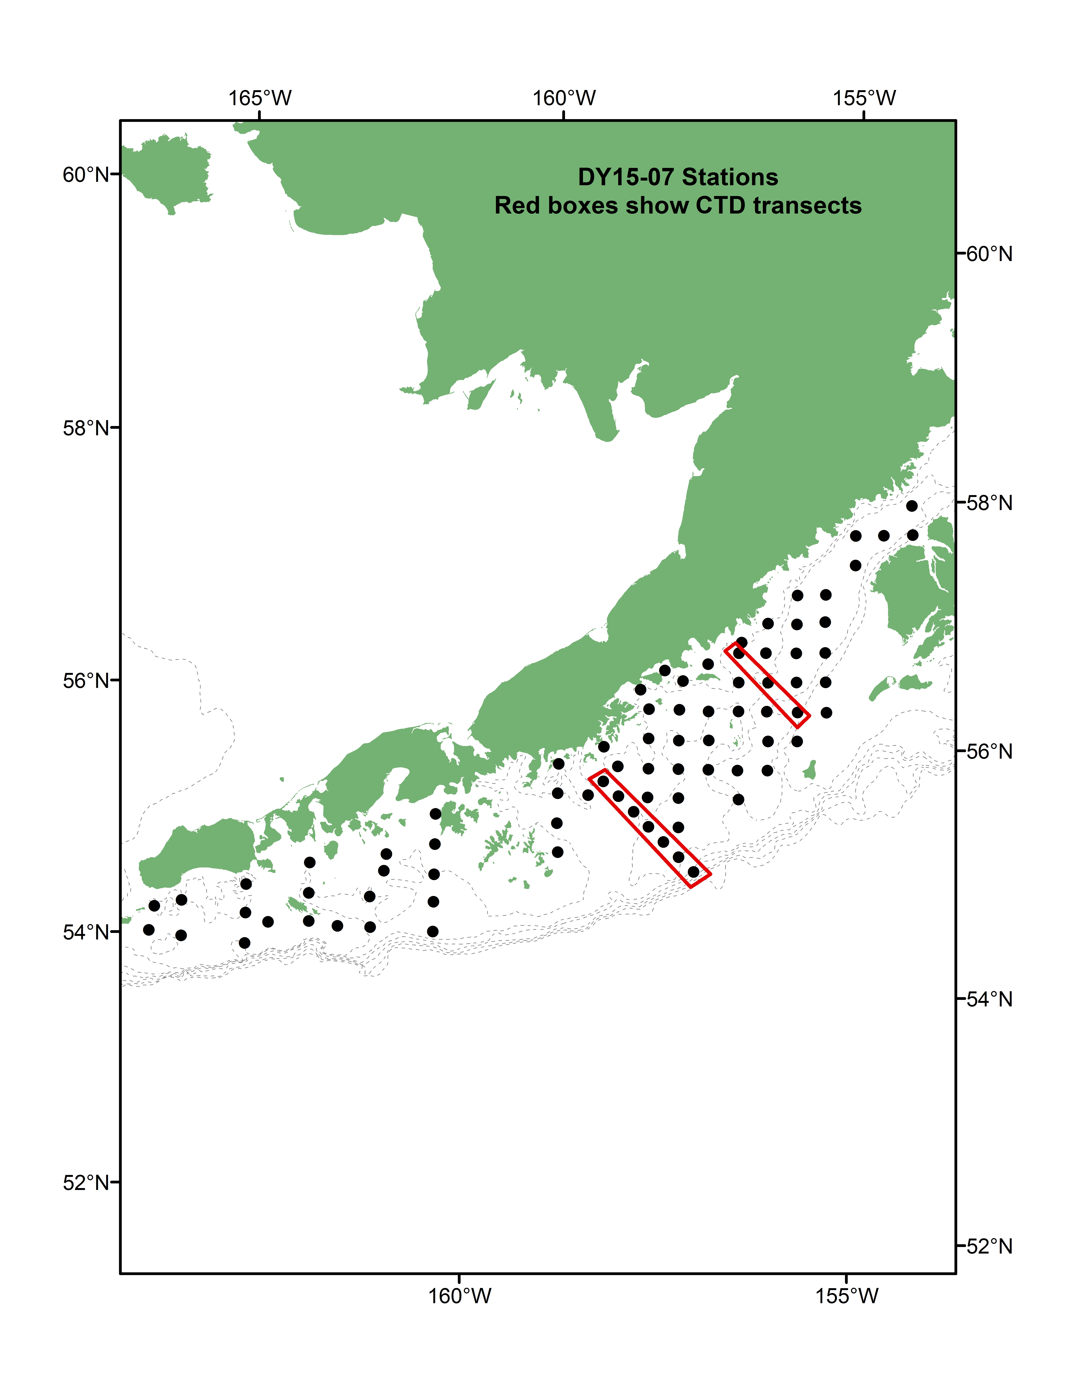

Table 1. DY15-07 cruise summary. Double click on table below for the complete cruise summary (embedded .pdf file).

